# Lab 4

## Ruijie Song

## Feb.19.2021

1 Histogram of an Image



Figure 1. race.tif

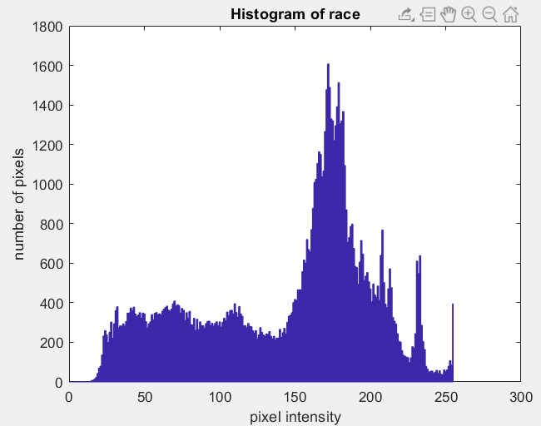



Figure 2. kids.tif

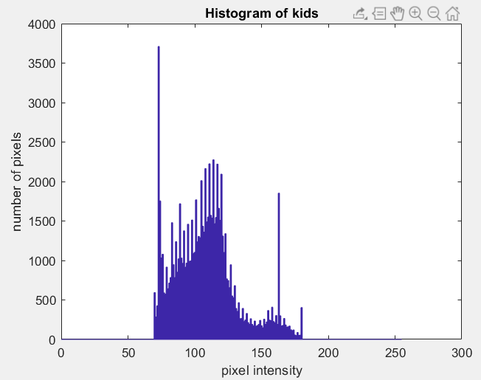

2 Histogram Equalization

2.



3.



4.



3 Contrast Stretching

2.



4.2 Determining the Gamma of Your Computer Monitor

1.



2 & 3.

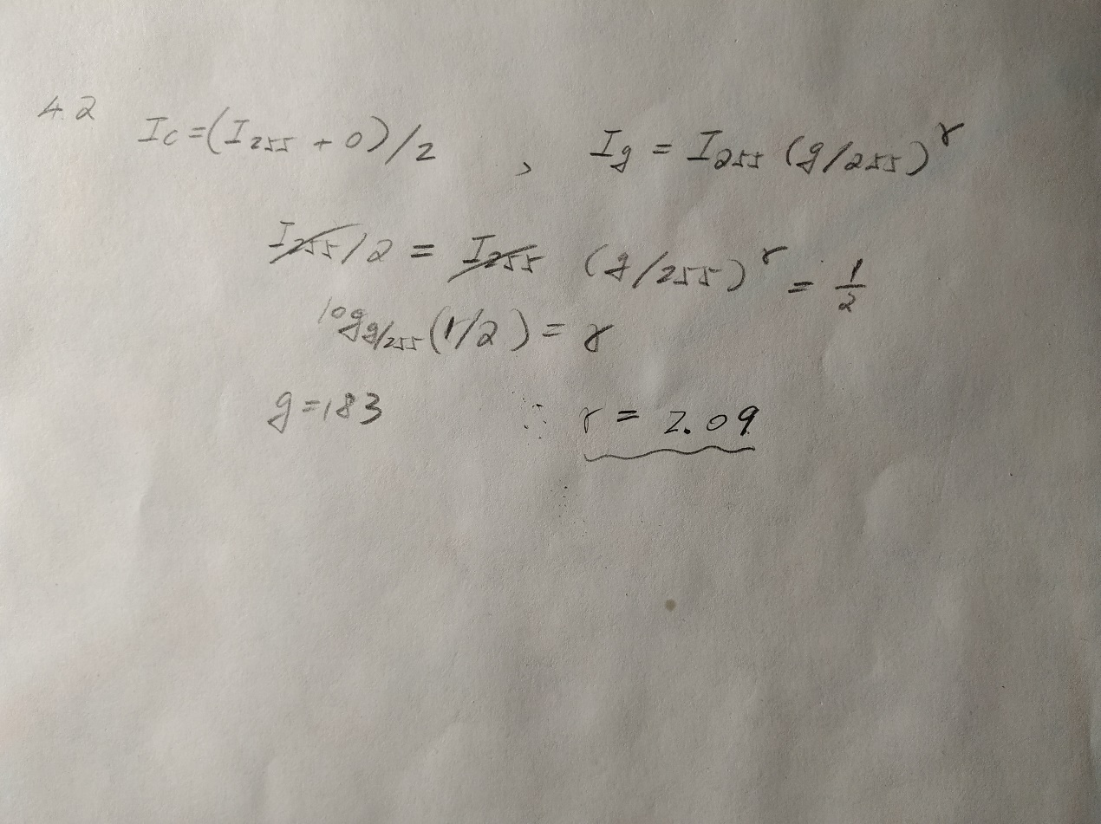

4.3 Gamma Correction

1. γ = 2.09



Figure . original image



Figure . corrected image

2.

Corrected image = 255 * (Original Image / 255)^(1/γ)

4.3 Gamma Correction

1.



Figure . corrected image of gamma15.tif

2.

